# **Constants and Macros Assignment**

1. **Write a function macro to find the smallest number in an array of integers**

**2.What are the differences between macros and constant. Can you replace a constant with a macro and vice versa? Give examples for your statements**

**Macro**: A macro is a preprocessor directive defined using #define. It is a textual substitution that occurs before the compilation starts. Macros are typically used for operations and constants.

**Constant**: A constant is a fixed value that is defined in the program using the const keyword. It is a variable-like entity whose value cannot be changed after initialization.

A constant can be replaced by a macro, but it doesn't make sense to replace a constant with a macro if there's no need for textual substitution.

**Example 1**: Replacing a constant with a macro:

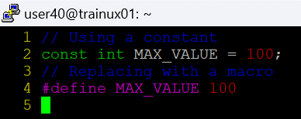

**Example 2:** Replacing a macro with a constant:

**3.Refer macro below**

#define MYPROD(x) (x *x)

WAP to invoke the above macro with inputs as below and display the result.

* 1. MYPROD(2+1)
  2. MYPROD(6+1)

**Do you get the expected answers as 9 and 49 in case a. and case b.?**

**ANS:**No I got the incorrect results because of the way the macro is expanded. The expression 2+1 gets substituted as 2+1 * 2+1, which leads to incorrect results.

**If not modify the code to produce the expected results. in above case**

**4.Write macro definitions with arguments for calculation of area of a triangle and circle.**

a.Use macros for both constants as well as formula evaluations.

b.Store these macro definitions in a header file and invoke the macros from the main function.

**main.c**

**Shapes.h**

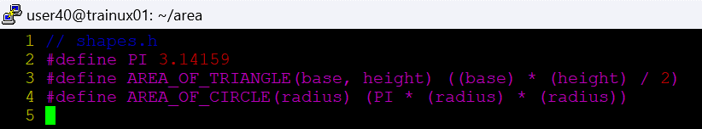

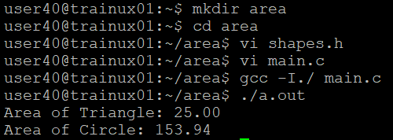

**5.Define a macro name MYPRINT as below.**

#define MYPRINT(x) printf(x)

Use the above macro conditionally only if a macro CUST_PRINT is defined , otherwise not to be used.

For eg refer the code and comments below.

int main()

{

MYPRINT("Hello World"); // will be displayed only when CUST_PRINT is defined

printf("Test"); // will be displayed always irrepective of CUST_PRINT

return 0;

}

Add the code to demonstrate the above behaviour.

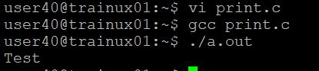

1. **Identify and use the macros to display**
   1. file name

b.function name

c.line of code

Show the usage with a code example

